Transition documents

1. **Basics:**

*Paths on computer*

CARLA_ROOT - where our CARLA package is housed, for example:

C:\Users\YourAccount\Documents\hbs\carla9.12\carla\Build\UE4Carla\0.9.13-1-g8854804f4-dirty\WindowsNoEditor>

*This is the package that we built from Carla.*

*This appears after running the `make package` command from here:* [*https://github.com/HARPLab/DReyeVR/blob/main/Docs/Install.md#building-dreyevr*](https://github.com/HARPLab/DReyeVR/blob/main/Docs/Install.md#building-dreyevr)

SCENARIO_RUNNER_ROOT - where scenario runner (for generating traffic challenges) is housed

C:\Users\YourAccount\Documents\hbs\carla9.12\scenario_runner>

1. **To get CARLA Running (basic mode):**

First, launch the UE4 instance of carla in the package. Using the **x64 NativeTools Command prompt:**

```

cd %CARLA_ROOT%

carlaUE4.exe

OR

CarlaUE4.exe -vr ## for VR mode

```

This launches a manual version of the CARLA engine. You should be able to do the following with this engine:

* drive around, start, stop (WASD).
* Reposition the camera using the arrow keys.
* Change the altitude of the camera using page up and page down

Finally, navigate to DReyeVR_AI.py in the PythonAPI/examples folder. This launches the autopilot which allows you to begin driving. It also generates some traffic.

```

cd PythonAPI

cd examples

python DReyeVR_AI.py

```

Controls:

* 1 (number) exits autopilot
* 2 spectator mode - you leave the car
* 3 engages autopilot again

1. **To enable scenario runner/ run a controlled example scenario**

[**https://carla-scenariorunner.readthedocs.io/en/latest/**](https://carla-scenariorunner.readthedocs.io/en/latest/)

Note: we are using scenario runner because we believe it is the best way to achieve the goals of the experiment, which Julian should have discussed with you. Please be sure that you understand the bigger-picture goals of the experiment. One of the challenges I had was constantly getting caught in the weeds of this CARLA stuff so I urge you to not make my mistake.

```

cd %CARLA_ROOT%

carlaUE4.exe  
  
python run_experiment.py --title "dreyevr_experiment" --route %SCENARIO_RUNNER_ROOT%\srunner\data\routes_training.xml %SCENARIO_RUNNER_ROOT%\srunner\data\all_towns_traffic_scenarios1_3_4.json 2 --debug

python run_experiment.py --title "dreyevr_experiment" --route %SCENARIO_RUNNER_ROOT%\srunner\data\hbs_routes.xml %SCENARIO_RUNNER_ROOT%\srunner\data\hbs_scenarios.json 1 --debug

```

The debug flag should allow you to see where a scenario should trigger

Optional to add autopilot / In a new x64 command prompt:   
  
```

cd %CARLA_ROOT%

cd PythonAPI

cd examples

python DReyeVR_AI.py

```

The car should now start driving. You will see SCENARIO 3 (the soda machine that has a pedestrian run out of it) appear on the side of the road underneath the SCENARIO 3 red square. In this case, I believe SCENARIO 3 is DynamicObjectCrossing referenced here: https://carla-scenariorunner.readthedocs.io/en/latest/list_of_scenarios/

In general: red squares with the word SCENARIO X indicate the site of a scenario. As you drive closer, the scenario will trigger.

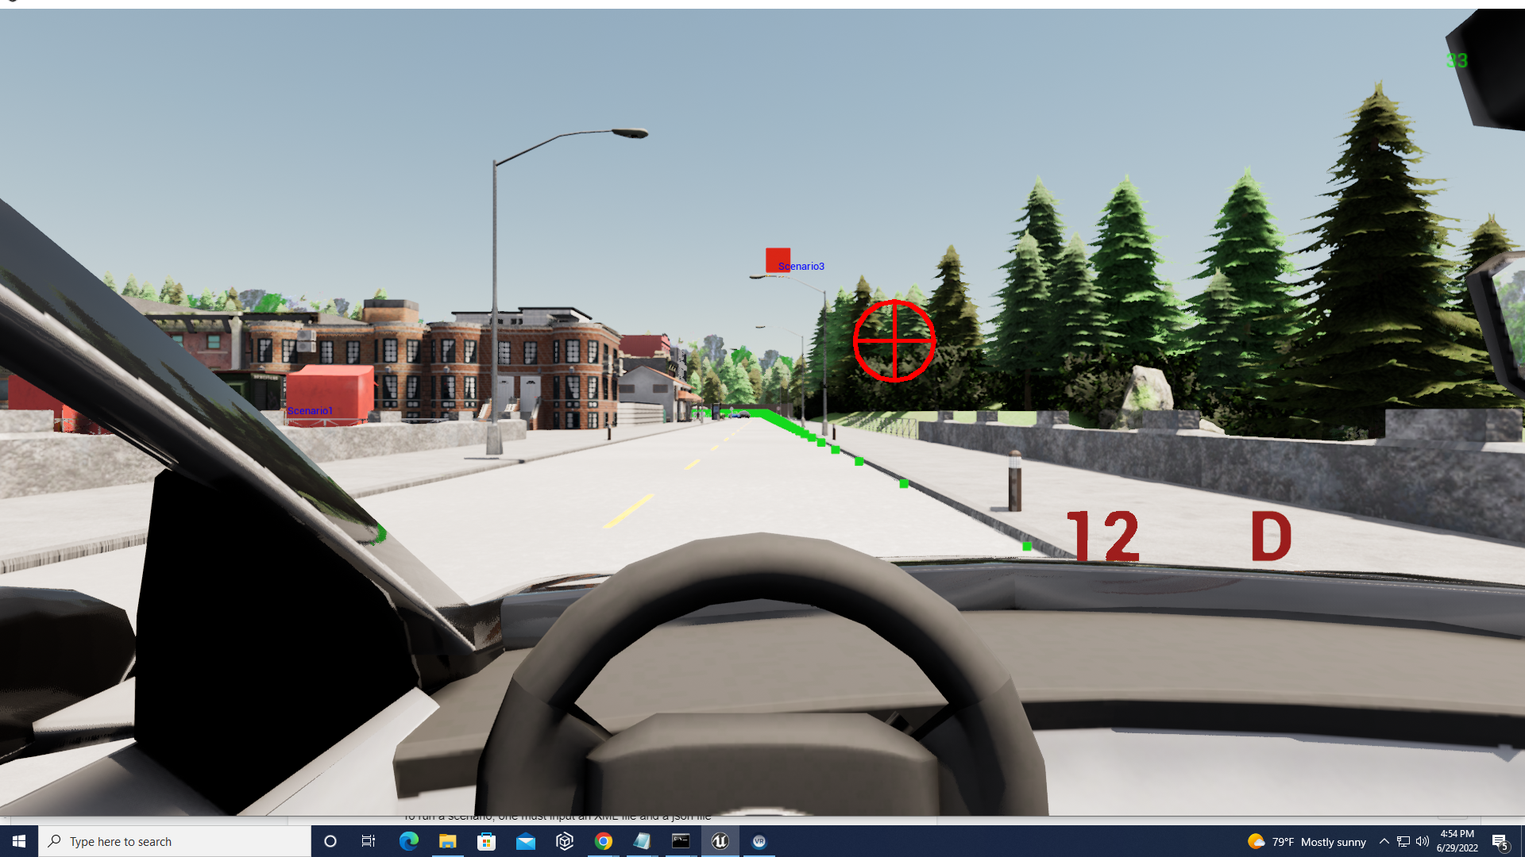

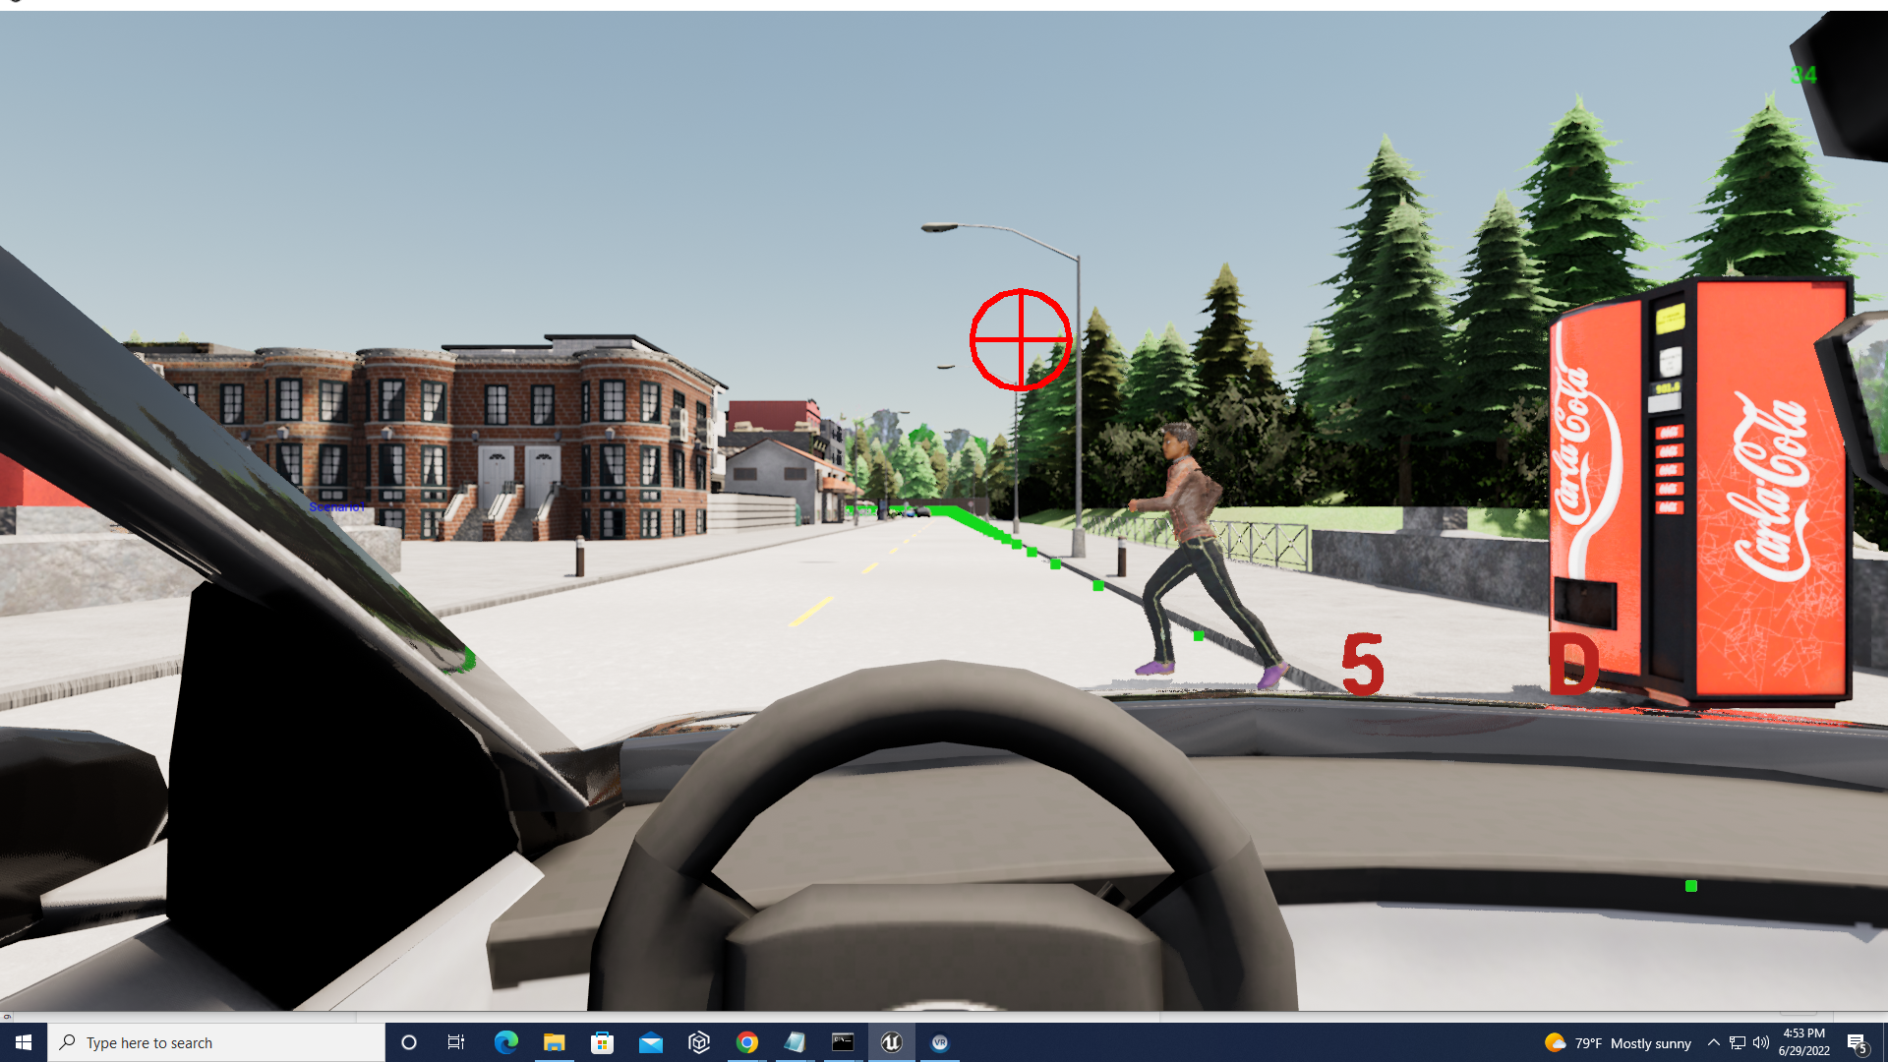

1. **Understanding scenario runner**

To run a scenario, one must input an XML file and a json file

The XML file contains route IDs and waypoints

The JSON file contains the scenarios themselves

# Launching Unreal Editor

C:\Users\YourAccount\Documents\hbs\carla9.12\carla>make launch

Inspecting waypoints:

<https://github.com/carla-simulator/scenario_runner/issues/696>

Unreal coordinates are in meters, while carla are in centimeters. So multiply carla coordinates by 100.

# TROUBLESHOOTING

## DReyeVR_AI timeout

Sometimes if you run DReyeVR_AI (the autopilot), you may get a timeout error, saying the autopilot is not able to connect to the simulator. This error is because CarlaUE4.exe was not shut down properly and the last instance is preventing the autopilot from connecting. To fix this:

* Open Task Manager in windows
* Look for any instance of CarlaUE4.exe
* Right click and choose “end tasks” to close the instance
* Make sure there’s no other instance of CarlaUE4.exe running
* Then run CarlaUE4.exe and DReyeVR_AI

## Shutting Down Carla and DReyeVR_AI

The order of shutdown matters.

DReyeVR_AI should always be shutdown before CarlaUE4.exe, otherwise, an instance of

CarlaUE4.exe will remain in the background and prevent the autopilot from reconnecting.